**HOME**

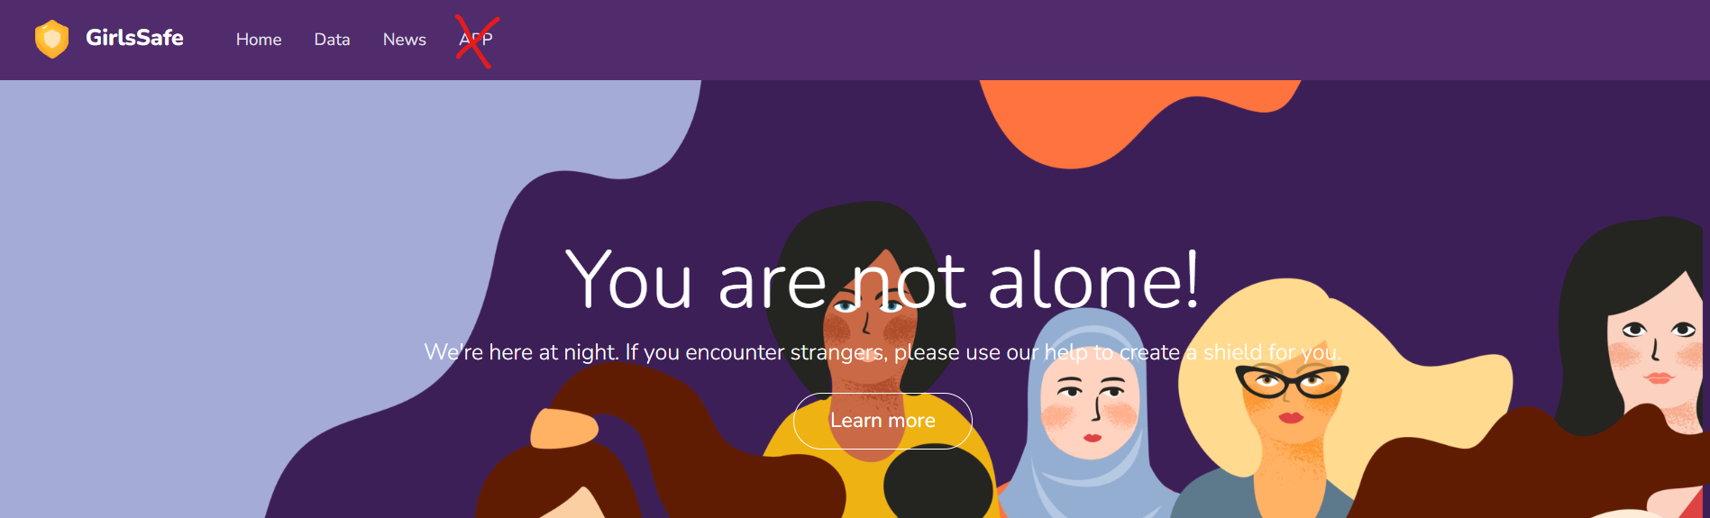

* Font colour - change the font colour since it’s a bit hard to read with the background or move the words to right hand.

updated

* Delete the `APP` tab → Create a button (`download app`) next to the `learn more`

Finished

Change learn more button to the scroll down page

* Change the `Data` tab to `Knowledge` or `Crime Charts` (?)

Change to ‘Knowledge’

* Put `Services` or `Features` or `Solution` tabs to introduce each of the features we offer to the user (?)

Finished solutions page

* Text : **You are not alone!** We’re here at night. If you encounter strangers, please use our help to create shield for you →
  + **Leaving you alone is not our choice.** We are here committed to protect you 24/7 and prevent crimes.
  + **Dare to be Aware!** We commit to keeping you safe. Turn attention to accident prevention. Leaving you alone is not our choice! (?)
  + **Be aware, take care!** We will get you covered in every possible scenario. Preventing crimes and protecting you is the only thing that we are good at.

It’s clear

* + **You are not alone!** Rest assured, we are here committed to protect you and bring the inexpressible comfort of feeling safe with a person to protect you from the worst of crimes.

I just change to ‘ Our Application Can Save Female Lives’ **, more clear**

* Make the banner image bigger (?) like this..using the original picture, it might be bigger enough to cover

updated

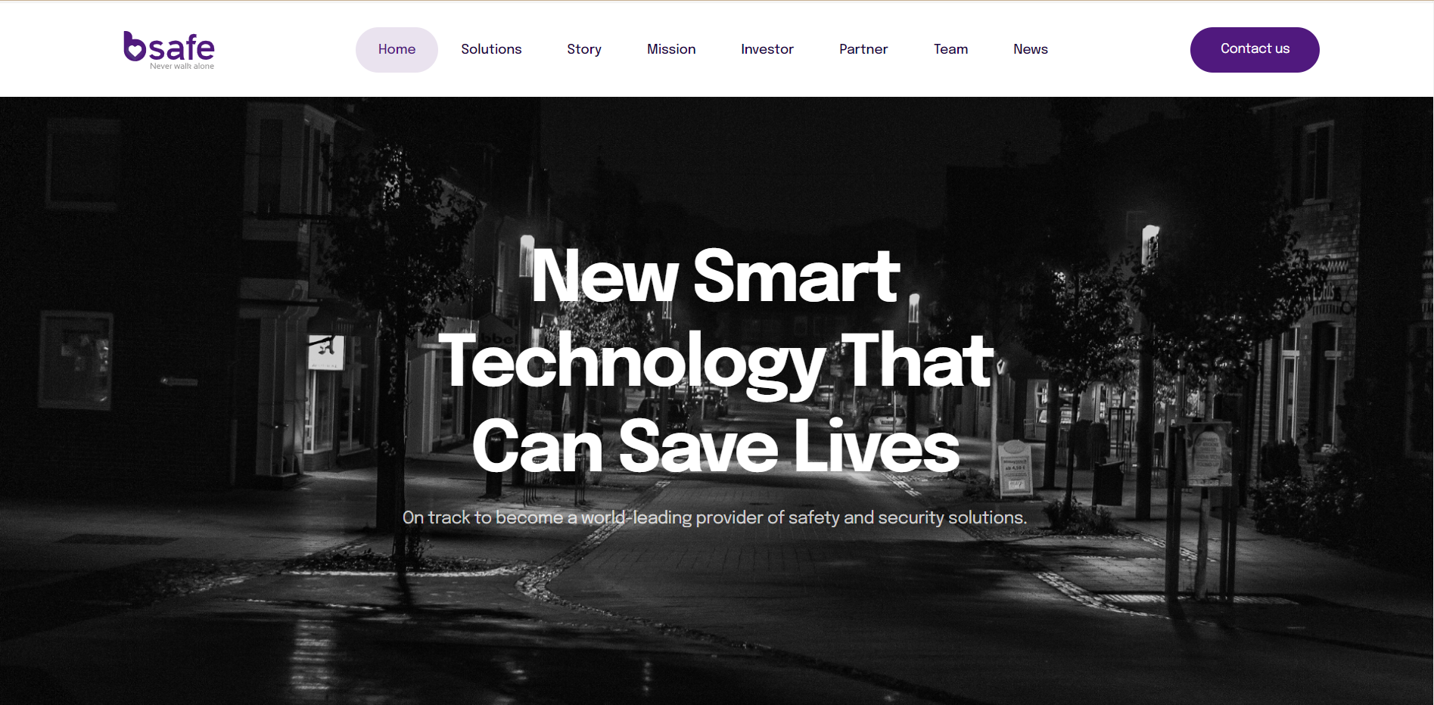

When click the learn more:

* Scroll down to this fact section:
* **Our work**

“The crime and violence against other people in Victoria continues to increase every year. In Victoria, every **8 minutes** another Australian is getting harmed or threatened by another person. **4 of 5 Australian women** over the age of 15 have been sexually harassed at some point in their lives. Ages **25 - 34** are the most risky period for someone to become a victim of crime.

It creates insecurity, fear and dread for women all over the world. We’re here committed to protect women by bringing the inexpressible comfort of feeling safe with a person to protect you from the worst of crimes.”

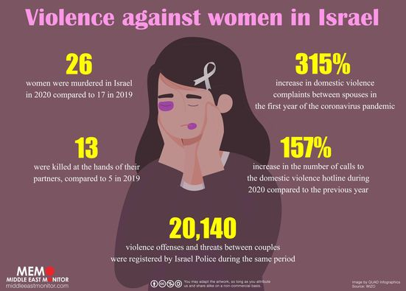

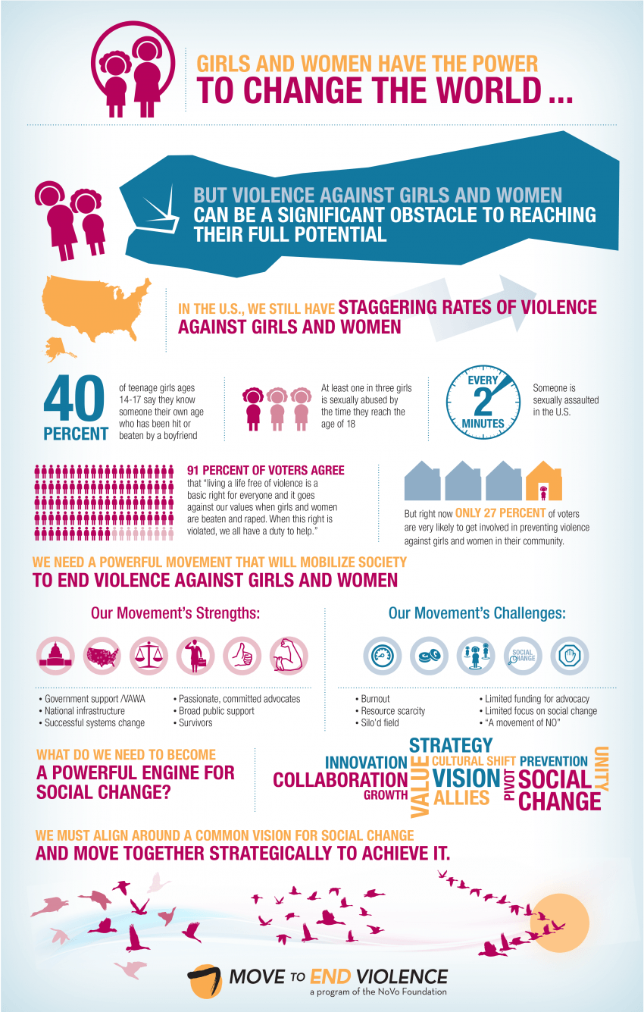

<https://www.preventconnect.org/2013/04/infographic-we-need-a-powerful-movement-to-end-violence-against-women-girls/>

**(maybe we can put some images like above to visualise this fact ?)**

* **Our Solutions**

1. **Call Police**

One click to call the police to escape the threatening situations right away

1. **Guardians (emergency contact?)**

Add your closest person as guardians and get peace of mind whenever you are

1. **Follow Me**

Let your friends and family join your journey virtually with live GPS-tracking

1. **S.O.S**

Play the S.O.S signal to attract attention and get help from surroundings.

1. **Fake Voice**

Automatically generate the sound you need to create a relatively safe environment

Guardians of the Girls, a project by GOT-G. You can share it with your friends. → *Everyone everywhere has the right to feel safe.*

**DATA**

* Goal: know the crime rate in Victoria

Visualisation: 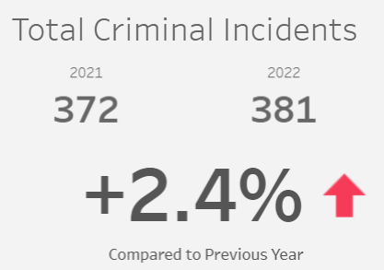

Total Crime Accidents in Victoria (2013 - 47409 records and 2022 - 64245 records)

**+35.5% in the last 10 years**

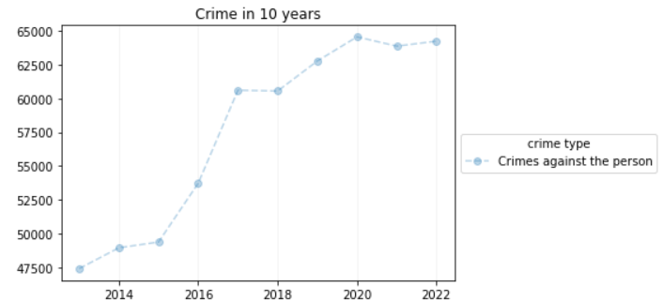

Total Crime against other person that happen in the last 10 years trend

Data:

Year Incidents Recorded

0 2013 47409

1 2014 48950

2 2015 49377

3 2016 53735

4 2017 60617

5 2018 60555

6 2019 62778

7 2020 64565

8 2021 63878

9 2022 64245

* Goal: know the type of crime that happen in Victoria

<https://echarts.apache.org/examples/en/editor.html?c=dataset-link>

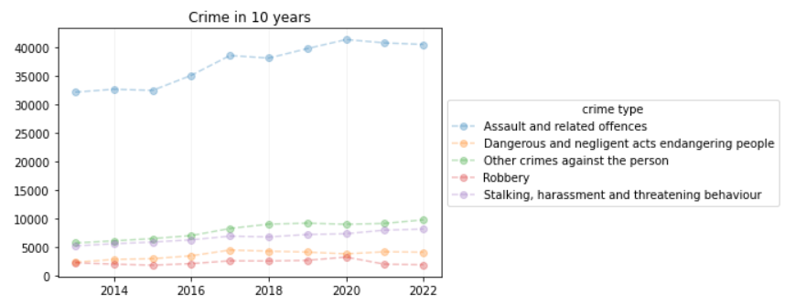

**The trend of the assault and related offence, other crime, and stalking, harassment and threatening behaviour tend to increase in each year.**

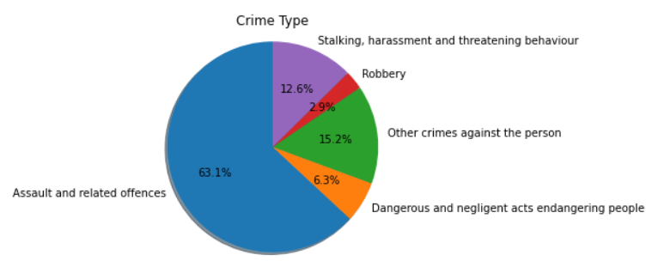

**More than half of crimes that happen are categorised in the assault and related offences. Then followed by other crime, and stalking, harassment, and threatening behaviour**

* Goal: number of street harassment in Victoria and each suburb

<https://echarts.apache.org/examples/en/editor.html?c=bar-race-country>

**Extra information:**

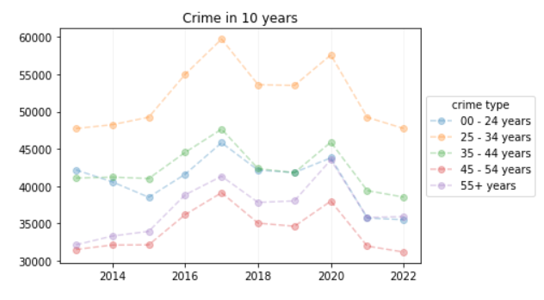

**Ages 25 - 34 are the highest risk years for getting offended by others. In this age range, people are 1.2 more likely to get offended than the general population of the victims.**

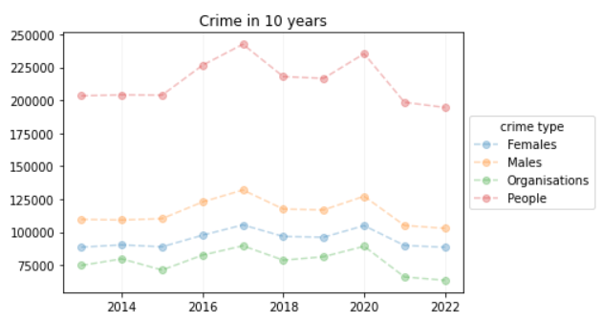

[**https://www.pmc.gov.au/office-women/economic-security/wess/supporting-women-be-safe-work-and-home**](https://www.pmc.gov.au/office-women/economic-security/wess/supporting-women-be-safe-work-and-home)